**De-Code (Deep Code Exercise)**

De-Code stands for Deep Code Exercise. This is the right website for learners to acquire Cyber Security fundamental concepts and knowledges. De-Code main feature is module, module is a collection of detailed explanation of a certain topic. De-code’s module will cover almost the basic until advance concept of learning Cyber Security. Such as cryptography, Linux tools usage, Python, Forensic, and many more.

De-Code was created for COMP6271-Software Engineering Project by :

|  |  |
| --- | --- |
| Renaldy | 2201730633 |
| Nico Christian | 2201737122 |
| Ryan Ricardo | 2201748403 |
| Stewart Sulivinio | 2201729524 |
| Karen Prisilia Iing | 2201732595 |
| Verenne Tanara | 2201736656 |

# De-Code Feature

## Home Page (Not Login)

On this page, every user can see brief description about the DE-CODE, such as frequently ask questions (FAQs) and pricing.



Home Page (Not Login)

## User Register Page (User)

On this page, every user can register themselves to get facilities from DE-CODE. Data needed is email, username, password, and confirmation for password. Every username must be unique because it is used as user identification.

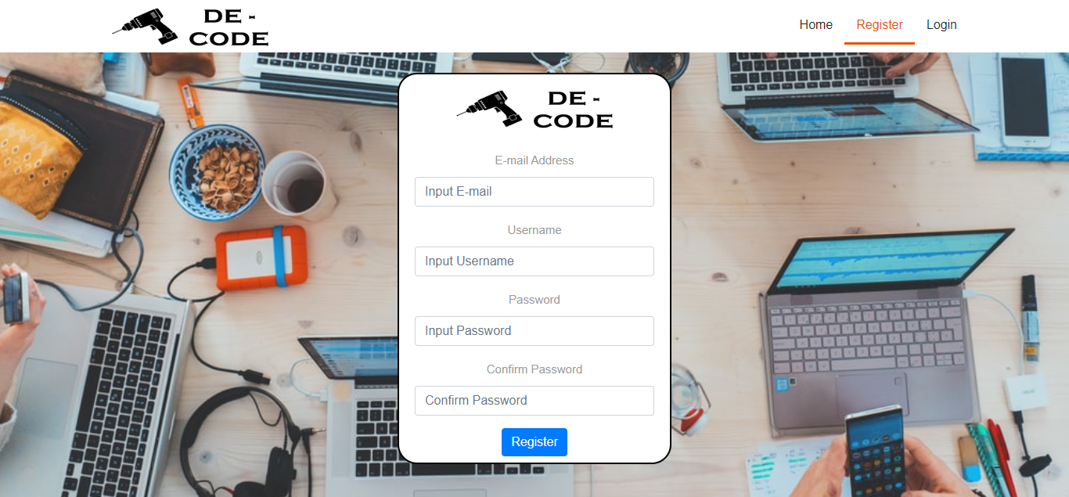

User Register Page (User)

## Login Page (User)

On this page, every user can login according to data that has been previously registered. Data needed is username and password.

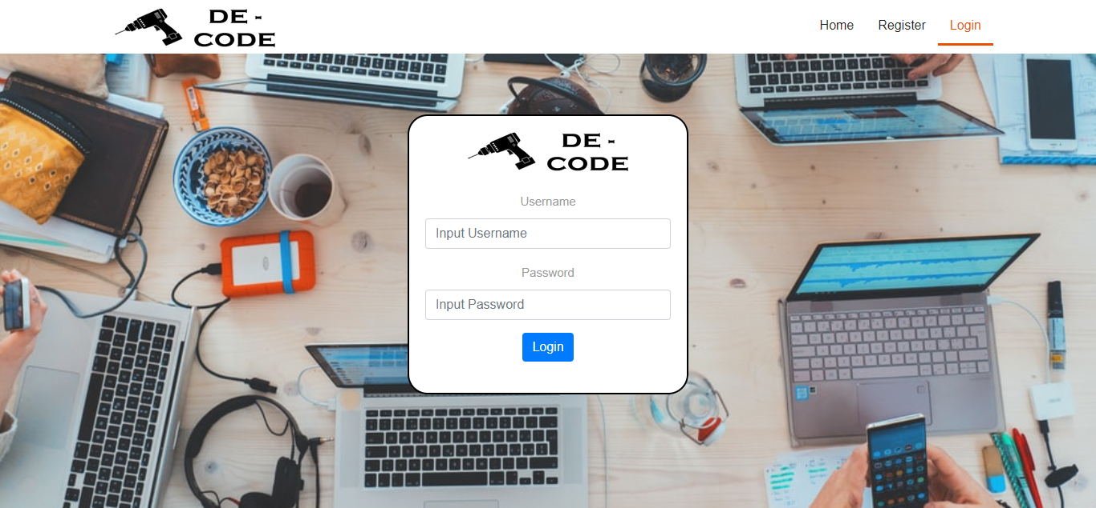

Login Page (User)

## Home Page (User)

On this page, the user can see the their data with the type of subscription. User can also see the lastest 3 information in The Hacker News (THN). And there are suggestions to user what course to take based on course created date.

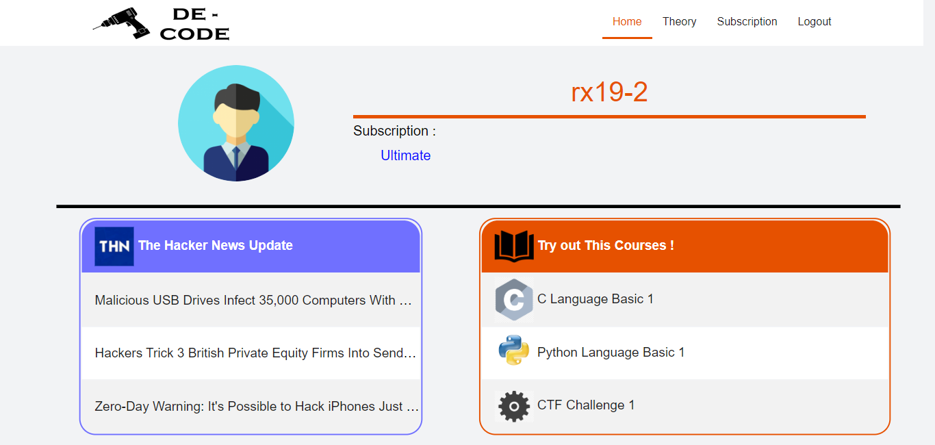

Home Page (User)

## Subscription Page (User)

On this page, every user can choose subscription they want. There are 2 types of subscription. The first is free where users can only see free course. The second is premium where users can only get premium course information. And finally the ultimate where users can get all course. After the user selects the selected subscription, the user will be directed to the payment page. The page will be display the amount to be paint and can return to the previous page. If user want to process the transaction, the webpage will show upload payment page. Files uploaded can only be image types. After that, user will wait for the admin to change user’s subscription.



Subscription Page (User)

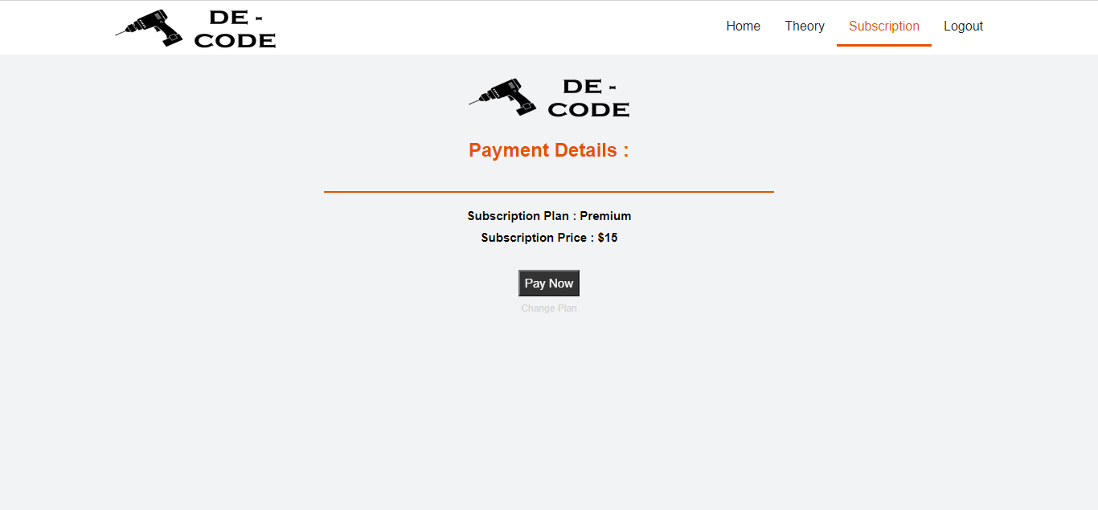

Receipt Page (User)

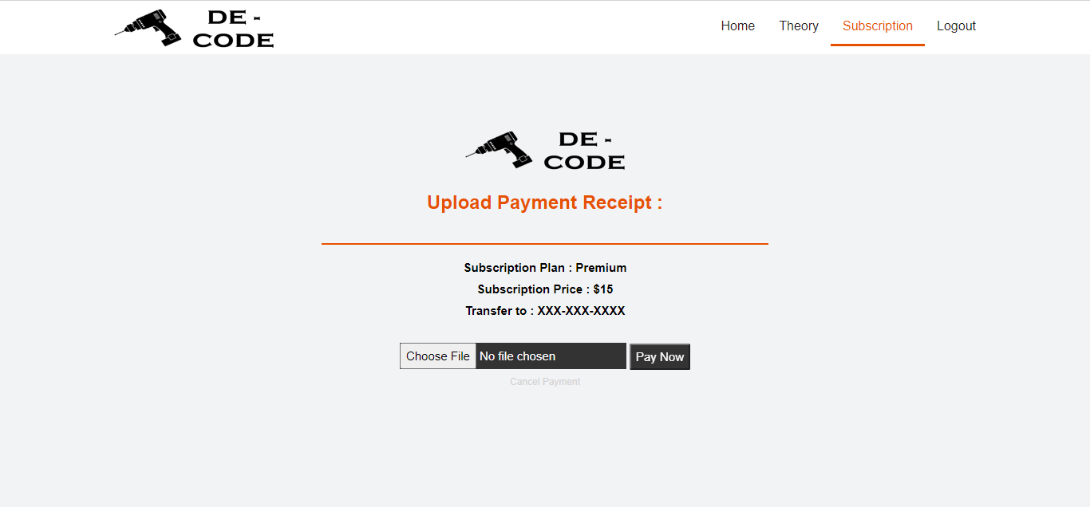

Upload Payment Receipt (User)

## Login Page (Admin)

On this page, every admin can login according to data that has been previously registered. Data needed is username and password.

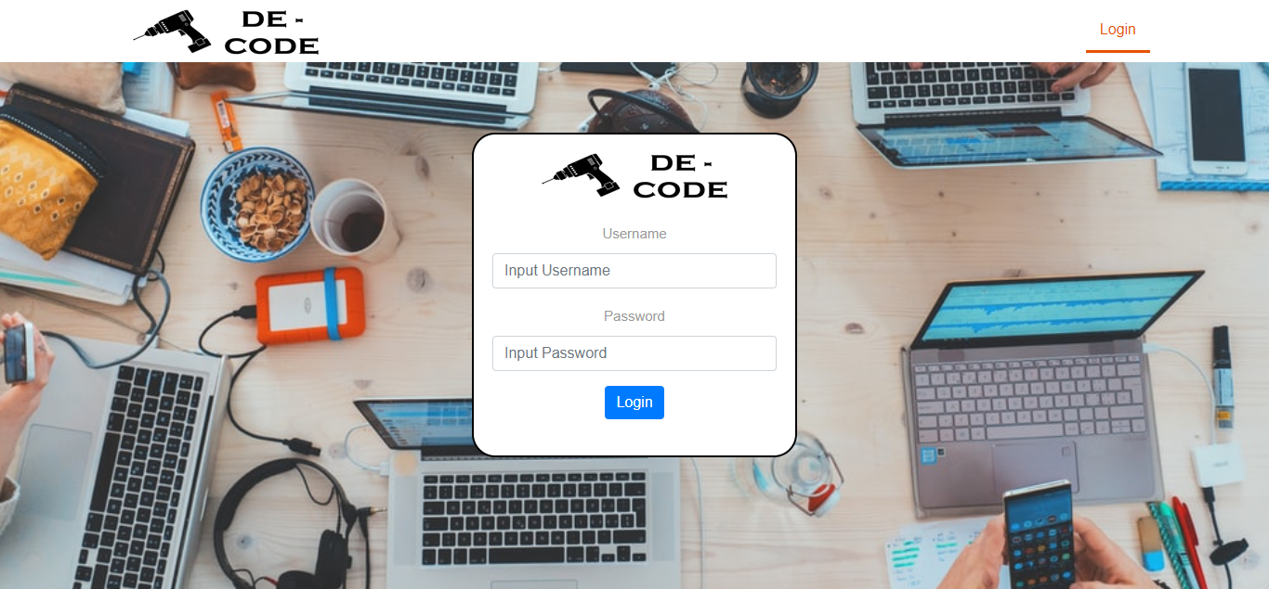

Login Page (Admin)

## Home Page (Admin)

On this page, every admin can manage users and theories.

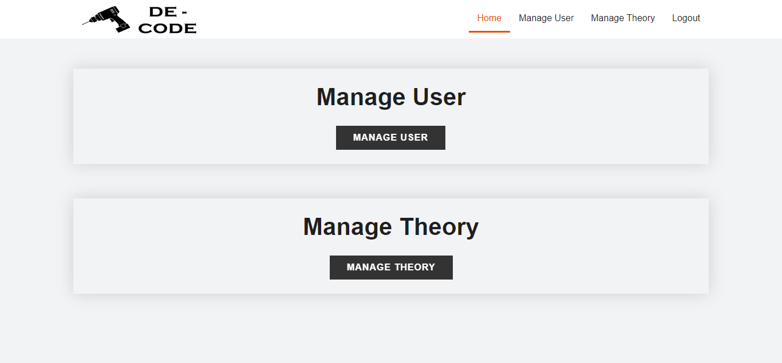

Home Page (Admin)

## Manage User Page (Admin)

On this page, every admin can see all users who have registered. Every admin can change each user’s subscription and ban user.

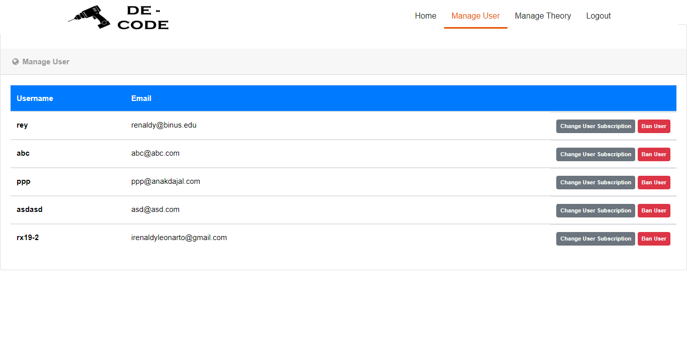

Manage User Page (Admin)

## Manage Theory Page (Admin)

On this page, every admin can see all theories. Every admin can add theories, edit existing theories, and delete existing theories.

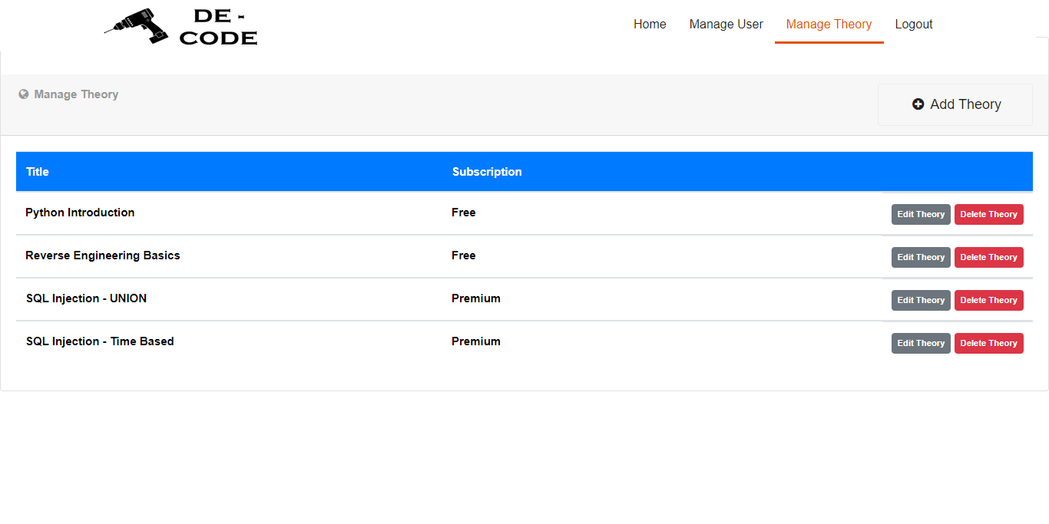

Manage Theory Page (Admin)

## Change User Subscription Page (Admin)

On this page, every admin can change each user subscription. Admin change each user’s subscription based on proof of transactions uploaded by the user.

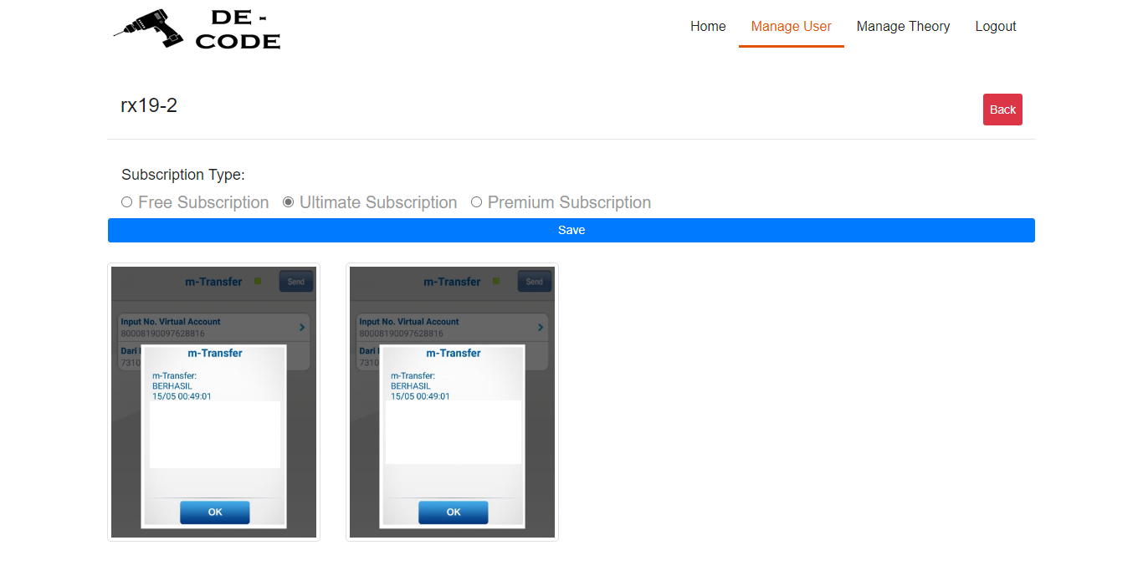

Change User Subscription Page (Admin)

## Add Theory Page (Admin)

On this page, every admin can add theories to share it to registered user. Data needed is theory title, theory subscription, and theory content.

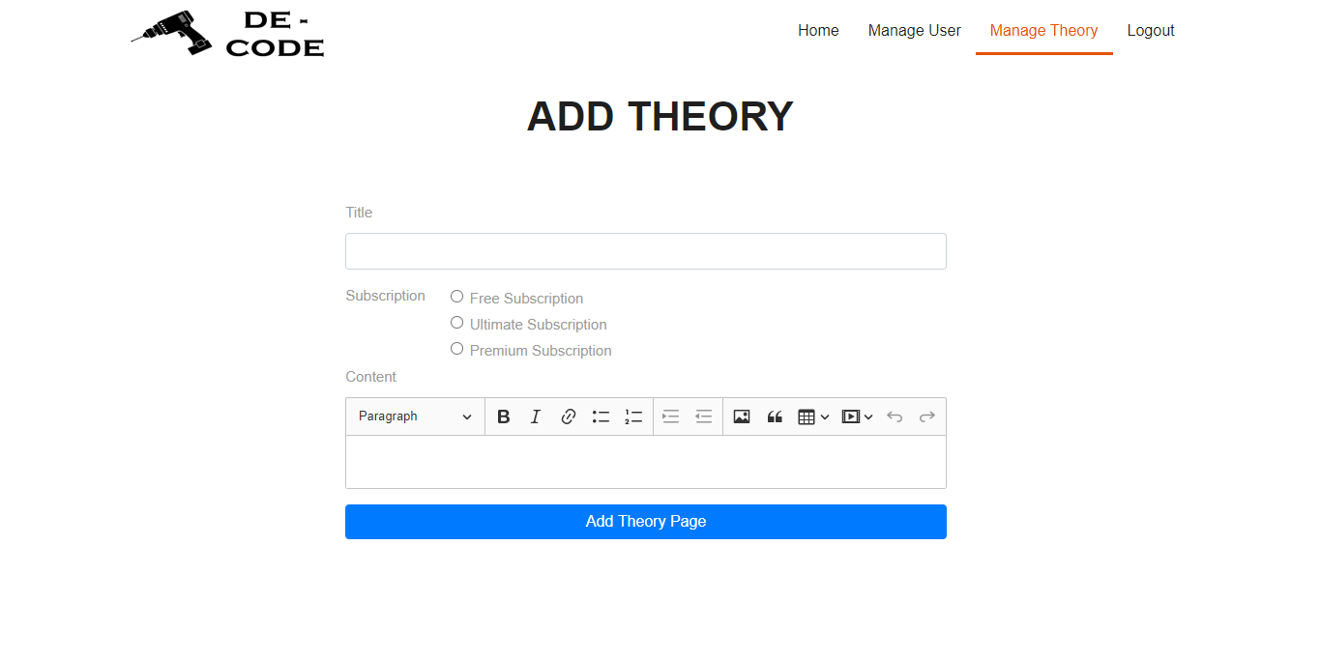

Add Theory Page (Admin)

## Edit Theory Page (Admin)

On this page, every admin can edit existing theories.

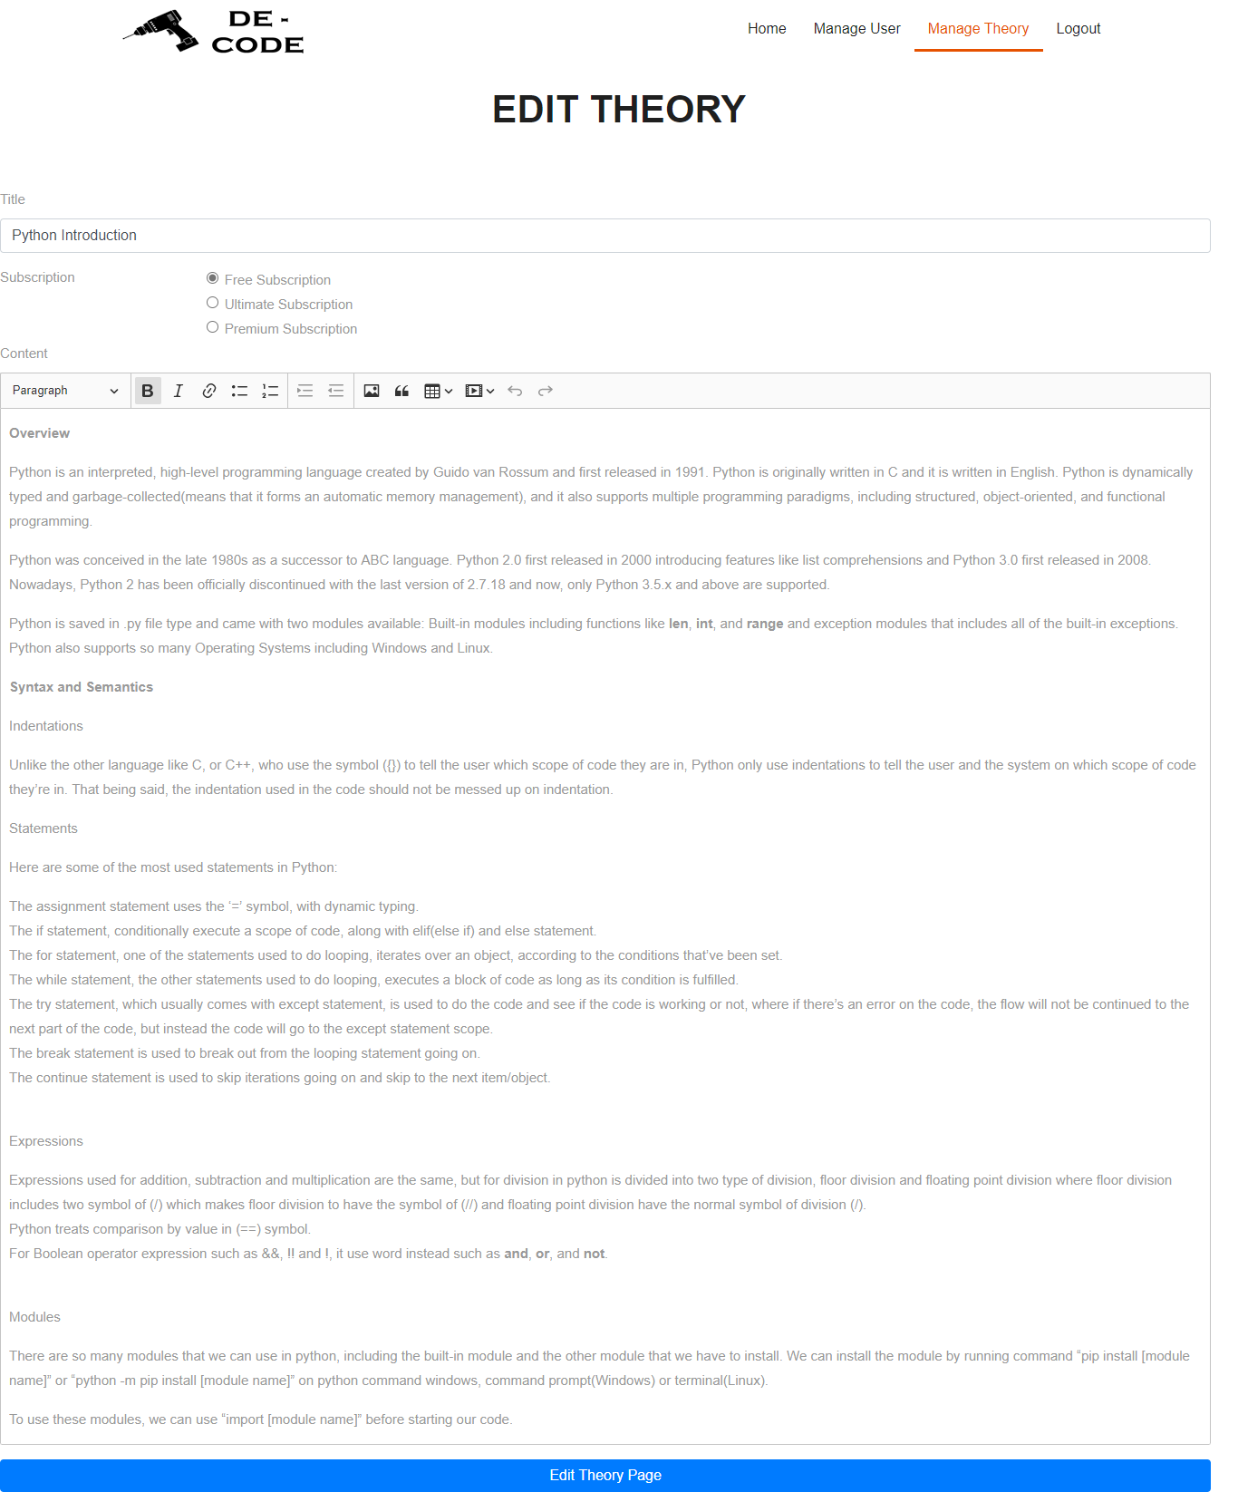

Edit Theory Page (Admin)